04 nights & 05 days Kashmir Tour

Day 01 Arrival Delhi

Arrive Delhi from Jaipur. On arrival transfer, check in at hotel.
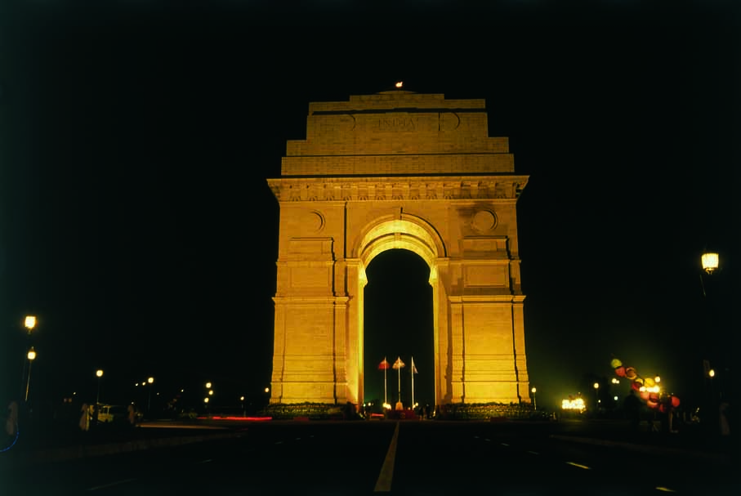
Delhi, the Empress of Indian cities has a fascinating history and a stimulating present. She has often been sacked and left naked and desolate. But she could not be despoiled of the incomparable situation that marks her for the metropolis of a Great Empire. The capital of India, Delhi has been the seat of power of a number of dynasties – the Rajputs, the Afghans, the Turks and the Mughals who continued their imperial line until the British. Scattered over are surviving ruins, remnants of mighty edifices, tombs of warriors and saints, which in an impressive sense of magnificence are memorials not of a single city but of supplanted nations.

Overnight at Hotel.

Day 02 Delhi - Srinagar

Morning transfer to airport to connect flight for Srinagar. You will be met by our representative on arrival & transfer to hotel.

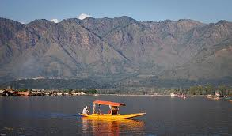
Srinagar is located in the heart of the Kashmir valley at an altitude of 1,730 m above sea level, spread on both sides of the river Jhelum. The Dal and Nagin lakes enhance its picturesque setting, while the changing play of the seasons and the salubrious climate ensures that the city is equally attractive to visitors around the year. Kalhana, the author of 'Rajtarangini’, states that Srinagri was founded by Emperor Ashoka (3rd Century BC). The present city of Srinagar was founded by Pravarasena-II, and Hiuen Tsang, who visited Kashmir in 631 AD, found it at the same site as it is today. Laltaditya Muktapida was the most illustrious ruler of Kashmir in the Hindu period, which ended in 1339 AD. King Zain-ul-Abidin (1420-70 AD), popularly known as ‘Budshah’, was a great patron of Sanskrit. Akbar captured Kashmir valley for the Mughals, who endowed Srinagar with beautiful mosques and gardens. The Sikhs overthrew the last Muslim ruler in the reign of Maharaja Ranjit Singh in 1819. In 1846 the Dogras secured the sovereignty of Kashmir from the British under the Treaty of Amritsar, and in 1947 the state of Jammu and Kashmir with Srinagar as its capital, became part of the Indian Union.

Afternoon enjoy 01 Hours Boat Ride on Dal Lake by a gondola Boat called ”SHIKARA” witness the ride on lake, called Venice of India & experience the aquatic life of Srinagar. Also see the scenic extravaganza of the Kashmir and enjoy the profusion of colors in the Paradise on Earth. While returning visit to the local crafts market and see the fine carved hand-made articles from Paper Machie & wood of a walnut

Overnight at Hotel.

Day 03 In Srinagar
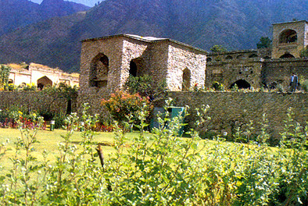
Morning after Breakfast: Take an excursion to Mughal Garden “Chasmashahi” (Royal Spring), "Nishat" (The Garden of Pleasure) and "Shalimar" (Abode of Love), also visit Shankaracharya Temple to get a bird’s eye view of Srinagar city.

Also, visit to downtown area of Srinagar City, Shah-i-Hamdan Shrine, Jamia Masjid Mosque and Hazratbal Shrine.

Overnight at hotel.

Day 04 In Srinagar

Morning after breakfast excursion to Gulmarg.

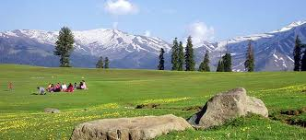
Gulmarg's legendary beauty, prime location and proximity to Srinagar naturally make it one of the premier hill resorts in the country. Originally called ‘Gaurimarg’ by shepherds, its present name was given in the 16th century by Sultan Yusuf Shah, who was inspired by the sight of its grassy slopes emblazoned with wild flowers. Gulmarg was a favourite haunt of Emperor Jehangir who once collected 21 different varieties of flowers from here. Today Gulmarg is not merely a mountain resort of exceptional beauty- it also has the highest green golf course in the world, at an altitude of 2,650 m, and is the country's premier ski resort in the winter.
The journey to Gulmarg is half the enchantment of reaching there-- roads bordered by rigid avenues of poplar give over to flat expanses of rice fields interspersed with picturesque villages. Depending on the season, nature's colours could be the translucent green of spring, summer’s rich emerald, or autumn’s golden hues, when scarlet chillies festoon windows of village homes. After Tangmarg, the climb to Gulmarg begins through fir-covered hillsides. At one point, known simply as View Point, travellers generally stop their vehicles for a few minutes and look out a spectacle of snow-covered mountains, almost within touching distance.

Overnight at hotel.

Day 05 Srinagar-Delhi ( by Flight )

Morning free.

Afternoon in time transfer to airport to connect flight to Delhi. On arrival in time transfer to airport to connect flight for onwards destination.

***************************************************************************************

